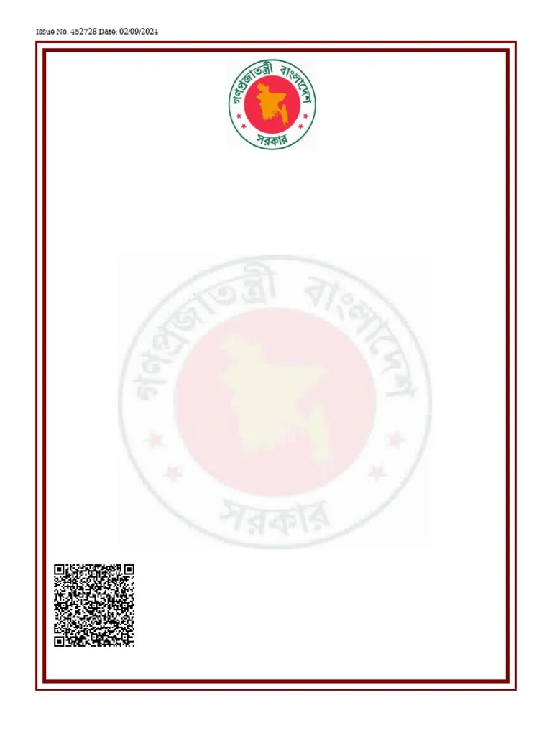
Issue No. 452728 Date: 05/06/2026

Certificate of Incorporation
(under Act XVIII of 1994)

No. C-175954/2026

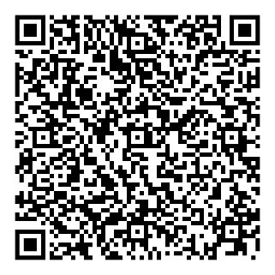
I hereby certify that MAME STUDIOS is this day incorporated under the Companies Act (Act XVIII) of 1994 and that Company is Limited.

Given under my hand at Dhaka this Fifth day of June two thousand and twenty-six.

By order of
Registrar

Assistant Registrar
Registrar of Joint Stock Companies & Firms
Bangladesh

